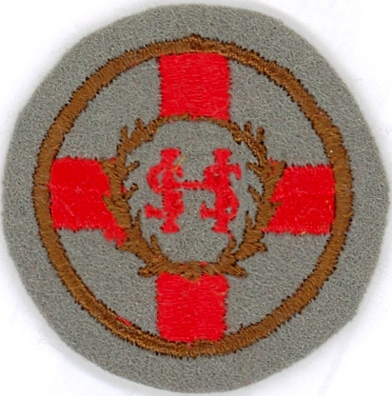

Sacred Heart Primary School
31 Reid Street
Bridgeton
GLASGOW G40 4AS
TEL. NO. 0141 554 5949
Natus Ad Patrare
Born to Achieve

Ref: EG/JM
Date: 30th October 2017

A CHANGE to the ENROLMENT PROCESS
P1 REGISTRATION
for AUGUST 2018

Dear Parents / Carers,

Glasgow City Council have changed the process in enrolling P1 children.

To support this change I can advise that Glasgow City Council are moving to an online application form for parents/carers to register their children/young people at the local catchment school.

· P1 Intake will take effect from November 2017
· Mid-term enrolments will take effect from January 2018

Parents/Carers should now use the online application form to apply for P1 and mid-term enrolments. Paper applications will only be available on request from Olympia Hub at Tel: 0141 287 8000 if parents/carers cannot access the internet. ALL paper forms MUST be sent to the hub for action.

Two adverts will be placed in the press on Thursday 12/10.2017 (The Daily Record) and Friday 13/10/2017 (The Scottish Sun). Two adverts will be placed in the Metro week beginning 23 October 2017 and 30 October 2017.

The enrolment week will be week commencing Monday 6 November 2017.

There will be an Open Day for any parent / carer wishing to visit the school prior to submitting the online form.

Our Induction Days will still continue in May.

I thank you for your ongoing support to make this a success.

Yours sincerely,

E GONZALEZ
HEAD TEACHER

